User manual

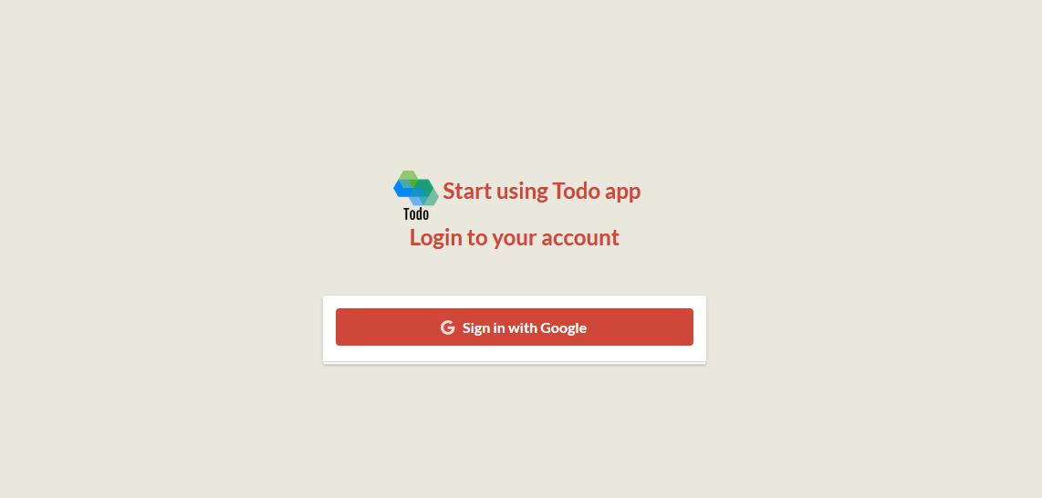

Click here to log out

Click here to login via google

Click here to add new task

Click here to search for a todo

Click here to sort via selected columns

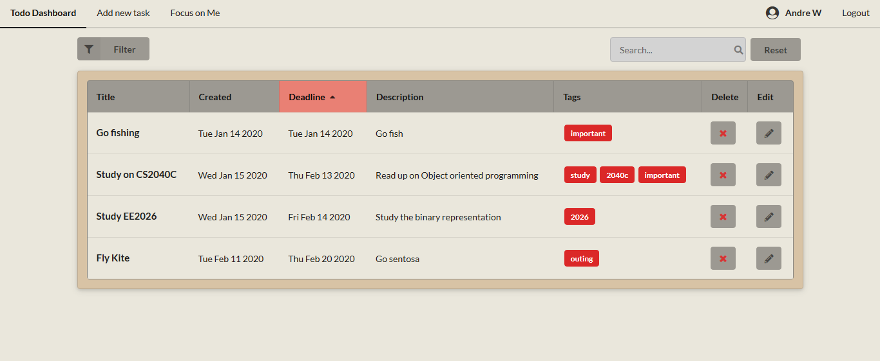

Click here to edit todo

Click here to delete todo

Click here to reset search

Click here to filter via tags

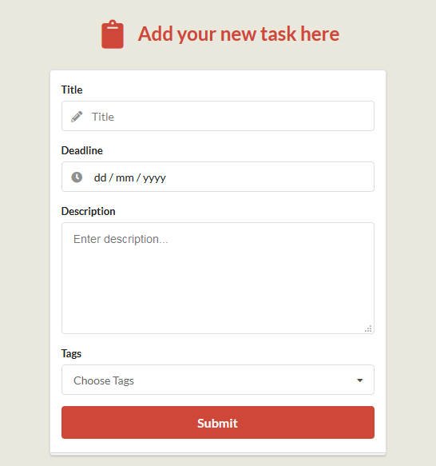

Click here to submit todo